Assignment 4

1. (a) Write a recursive method, sum(L), in pseudo-code to calculate the sum of the integers in the list L of integers. First use positions to traverse the list. See the hint in the lecture notes. Analyze line by line your algorithm.

Algorithm: sum(L)

p $←$ L.first -------------------O(1)

return sumHelper(L, p)--------------------------O(1)

Algorithm:sumHelper(L,p)

sum $←$ p.element

if L.isLast(p) then --------------------O(1)

return sum -----------------------------O(1)

else

x $←$ sumHelper(L, L.after(p)) ------------O(n)

return sum + x ----------------------O(1)

so the running time is ------**O(n)**

(b) Write a second recursive algorithm that uses the rank-based operations to traverse the list to calculate the sum. Analyze your algorithm line by line.

Algorithm: sum(L)

return sumHelper(L, 0) ----------------O(1)

Algorithm:sumHelper(L,r)

sum $←$ L.atRank(r).element

if r $≥$ L.size() then--------------------O(1)

return sum-----------O(1)

else

x $←$ sumHelper(L, r+1) -------------------O(r)

return x+sum -------------------O(1)

--- so the running time is ------**O(r)**

(c) Choose the better algorithm, either (a) or (b), then implement that algorithm in JavaScript using the List.js file provided in a previous assignment

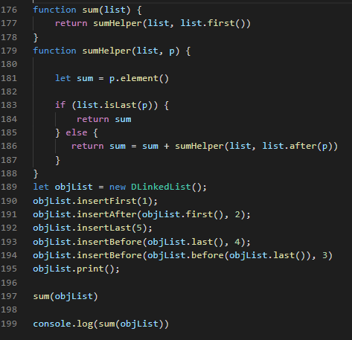

B. Design a pseudo-code recursive method, findMax(L), that returns the maximum number in the list L. Implement in JavaScript using the List.js file provided previously.

Algorithm: findMaximum(L)

return findMaximumHelper(L, L.first())--------------------O(1)

Algorithm: findMaximumHelper(L,p)

if L.isLast(p) then ---------------------------------O(1)

return p.element() ----------------------------------O(1)

else

x $←$ findMaximumHelper(L, L.after(p)------------------------O(n)

return max(x, p.element()) -----------------O(1)

so the running time is ---------**O(n)**